Blocking Beethoven

Mikayla dropped her head onto her open math book, crossed her

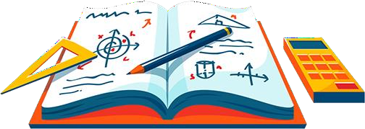arms so her shoulders blocked her ears, and groaned. Her room was practically vibrating from her brother Liam practicing piano again, and there was no way that she could focus on math with all o f that noise.

“Mom!” she shouted. “Liam is playing way too loud again!”

Mikayla’s mom popped her head into the room. “Sorry honey,” she said, “Were you calling me?”

“Yes!” Mikayla answered, “I’m surprised you heard me since Liam’s making so much noise. I can’t study for tomorrow’s math test when he is banging away on that piano.”

“Right,” said Mikayla’s mom thoughtfully. “It seems we need to find

a way for everyone to get their work done at the same time

because Liam needs to practice for his reci tal on Saturday, and you

need to ace your math test.”

Mikayla nodded.

“Let’s think about this,” her mom continued. “Sound is energy

created by the vibration of an object. When Liam hits a piano key, a tiny hammer strikes a metal string in the piano caus ing it to vibrate.

The vibration of the string causes the surrounding air to vibrate, and

those vibrations travel through the air as sound waves.”

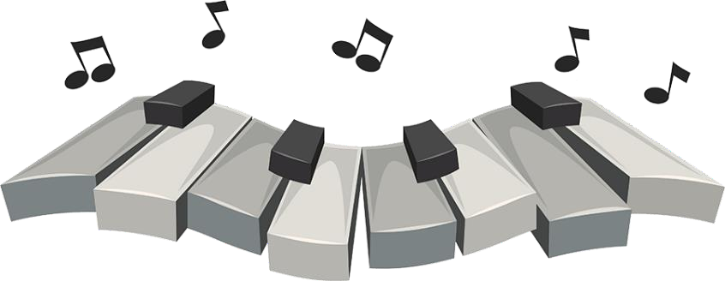“Well, I’m drowning in those sound waves,” Mikayla said.

“As you’ve noticed, those sound waves

eventually reach our ears. Our outer

ear funnels the vibrations in the air into the middle of our ears where our eardrum sits. Our eardrums then begin to vibrate in the same

pattern. The vibration of our eardrums results in signals that our brains interpret as sound. And that’s what is interrupting your

homework.”

“You’re not kidding,” Mikayla said. “So, can you please make him stop?”

“Maybe we can figure out a way to interrupt that process. Then you

can get your studying done.”

“Mom, that’s easy. Let me explain,” Mikay la said in her most grown-

up and patient voice. “First, you tell Liam to stop hitting the piano keys with his fingers, then the keys won’t cause the hammer to hit the strings, and then the strings won’t vibrate, and there will be no sound waves flooding into my ears and ruining my chances of

getting into university.”

“Very funny girl,” Mom said with a smile. “We could silence the

piano by stopping the strings from vibrating, but then Liam won’t get

the practice that he needs. However, the sound vibrations h ave to travel through the air to reach our ears. How can we block that?”

“OK, that’s easy too,” Mikayla sighed. “We just hook Dad’s big pump up to the house and pump out all the air. Then the sound can’t

travel.”

Mom looked thoughtful. “Well, scientifical ly speaking, you are

correct. Sound vibrations need a medium, like air or water, to travel through. I f there was no air to vibrate, there would be no sound. In

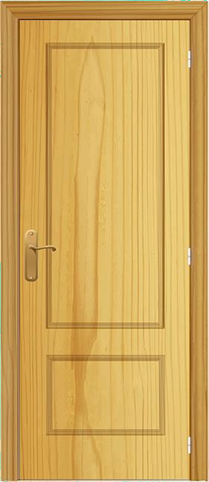fact, in the vacuum of outer space, it is completely quiet. However, we need air to breathe, so your plan won’t

work. Let’s try closing your door and block

that vibrating air from coming into your

room.”

Mikayla and her mom closed Mikayla’s door and window, and shoved a blanket around the door until they couldn’t see any light

coming through. The room seemed

completely sealed. Unfortunately, just at the moment, Liam stuck up a rousing version of

Beethoven’s ninth symphony, and they could

hear every chord.

Mikayla covered her ears. “Why does he

have to play so loud?”

“Hmmm… I guess closing your door is not going to solve our

problem,” Mikayla’s mom conceded. “The vibrating air outside of

your room is causing your walls to vibrate, which causes the air inside your room to vibrate. So, we can still hear the piano. We made it quieter, but still not quiet enough.”

“Well, can’t you just tell Liam to practice more quietly?” Mikayla

asked.

“Sure,” Mom replied. “The energy something makes when it vibrates produces sound waves that have a definite pattern. If Liam hits the piano keys harder, then the string vibrates with more energy and the sound waves are larger. When he plays lightly, he reduces the

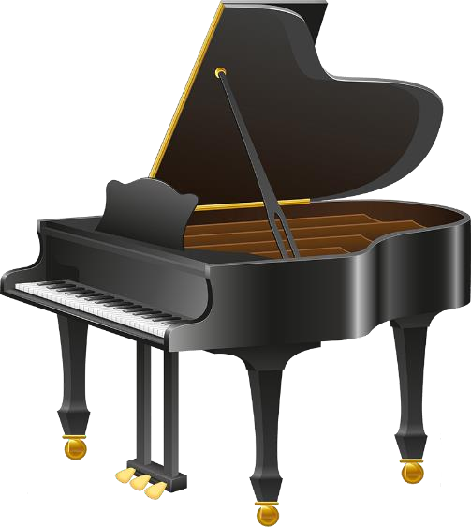energy of the string vibration, creating smaller, quieter sound waves. I could ask him to play more quietly, but I don’t think it would solve our problem completely.”

“Yeah,” Mikayla groaned. “No matter how gently he plays the high notes, they make my teeth hurt.”

“That’s a bit melodramatic.” Mikayla’s mom

noted. “High and low notes do vibrate

differently. If a sound has higher pitch, then it means the sound wave is vibrating much faster

or has a higher frequency. A low frequency pitch

vibrates slower and sounds deeper. Liam needs all of the keys to

practice though, so we can’t ask him to only play the low notes.” “Great, so I just fail my math test then,” Mik ayla sighed.

“No, that’s not the answer,” Mom reassured her. “How can we figure

out a way to reduce the vibrations that your ears are exposed to?"

“Oh, OK,” Mikayla said in frustration. “Maybe I ’ll just wrap my head in a giant marshmallow.”

“That’s it!” Mom exclaimed, dashing out of the room. Hearing the

backdoor slam, Mikayla went to the window and saw Mom heading into her woodworking shop in the backyard. A few minutes later, her Mom burst back into her room.

“Marshmallows are the answer!” she cried, holding up a bulky pair of ear muffs she used when operating loud machinery in the shop.

“These ear muffs have a tough outer shell, but inside they are filled with soft foam that’s designed to not vibrate at frequencies we can hear. Give them a try.”

Mikayla put on the big ear muffs, and Beethoven was instantly

silenced. Mikayla gave Mom a thumbs-up. Marshmallows were the answer indeed.

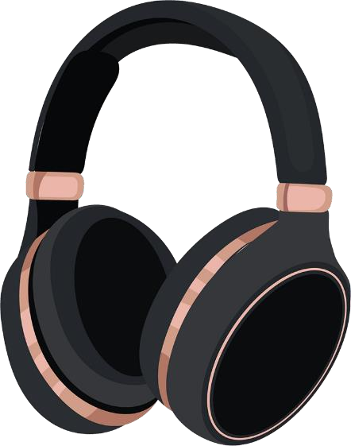

**Blocking Beethoven (exercises)**

# Multiple Choice

If something is vibrating very quickly, it will likely:

* 1. have a very low sound like tuba
  2. have a really quick beat like dance music
  3. have a really high sound like a flute
  4. be very soothing to listen to

If something is vibrating very slowly it will likely:

1. sound like tinker bells
2. not have enough energy to vibrate your ear drum
3. sound very deep and low like a foghorn
4. try to catch up to the quick waves

What is a “vacuum” as discussed in the story .

1. A machine for cleaning carpets.
2. A space that is completely empty of all particles, including air.
3. A room that is so noisy that you cannot hear yourself think.

# Sounds can be high-pitched or low-pitched. They can also be loud or soft. Fill in this chart with examples of sounds of each type:

|  |  |
| --- | --- |
| **High-pitched sound** | **Loud sound** |
|  |  |
| **Low- pitched sound** | **Soft sound** |
|  |  |

1. **Short Answer**

Do you think you can hear anything under water? Why or why not?



**Blocking Beethoven (answers)**

# Multiple Choice

c. have a really high sound like a flute

c. sound very deep and low like a foghorn.

b. A space that is completely empty of all particles, including air.

# Sounds can be high-pitched or low-pitched. They can also be loud or soft. Fill in this chart with examples of sounds of each type: ( Answers may vary)

|  |  |
| --- | --- |
| **High-pitched sound** | **Loud sound** |
| school bell whistle | car’s horn  hammer banging |
| **Low- pitched sound** | **Soft sound** |
| cow’s moos  bass guitar | bird’s chirp  hiss of snake |

1. **Short Answer** (Answers may vary)

Yes, you can hear under water. Even though there is no air, the sound can travel through vibrations of the water molecules.